Day 396 — Deep Learning Complete Revision
Complete Revision Notes | Neural Networks • Activation Functions • Forward/Backprop • Loss Functions • Optimizers • Training Dynamics
Learning goal: master foundational and advanced deep learning concepts: understand the biological and mathematical anatomy of artificial neurons and multilayer perceptrons (MLP); evaluate activation functions (Sigmoid, Tanh, ReLU, Leaky ReLU, Softmax); trace forward propagation and backward propagation via the multivariate chain rule; contrast regression and classification loss functions; master gradient descent paradigms (Batch, Stochastic, Mini-batch); analyze adaptive optimizers (SGD, Momentum, RMSprop, Adam); and calibrate training dynamics (epochs, batch size, learning rate schedules).

1. Biological & Artificial Neurons: The Perceptron Model
Deep Learning is a subset of machine learning based on Artificial Neural Networks (ANNs) with multiple hidden layers. Inspired by biological neurobiology, an artificial neuron receives input signals via incoming dendrites, computes a weighted linear combination offset by a scalar bias, and fires an output signal through an axon via a non-linear activation function.
Without the non-linear activation function, any arbitrarily deep neural network would simply collapse into a single linear regression model: W₂ (W₁ x + b₁) + b₂ = (W₂ W₁) x + (W₂ b₁ + b₂). Non-linearity is what grants deep neural networks the mathematical capability to serve as Universal Function Approximators (Cybenko, 1989).
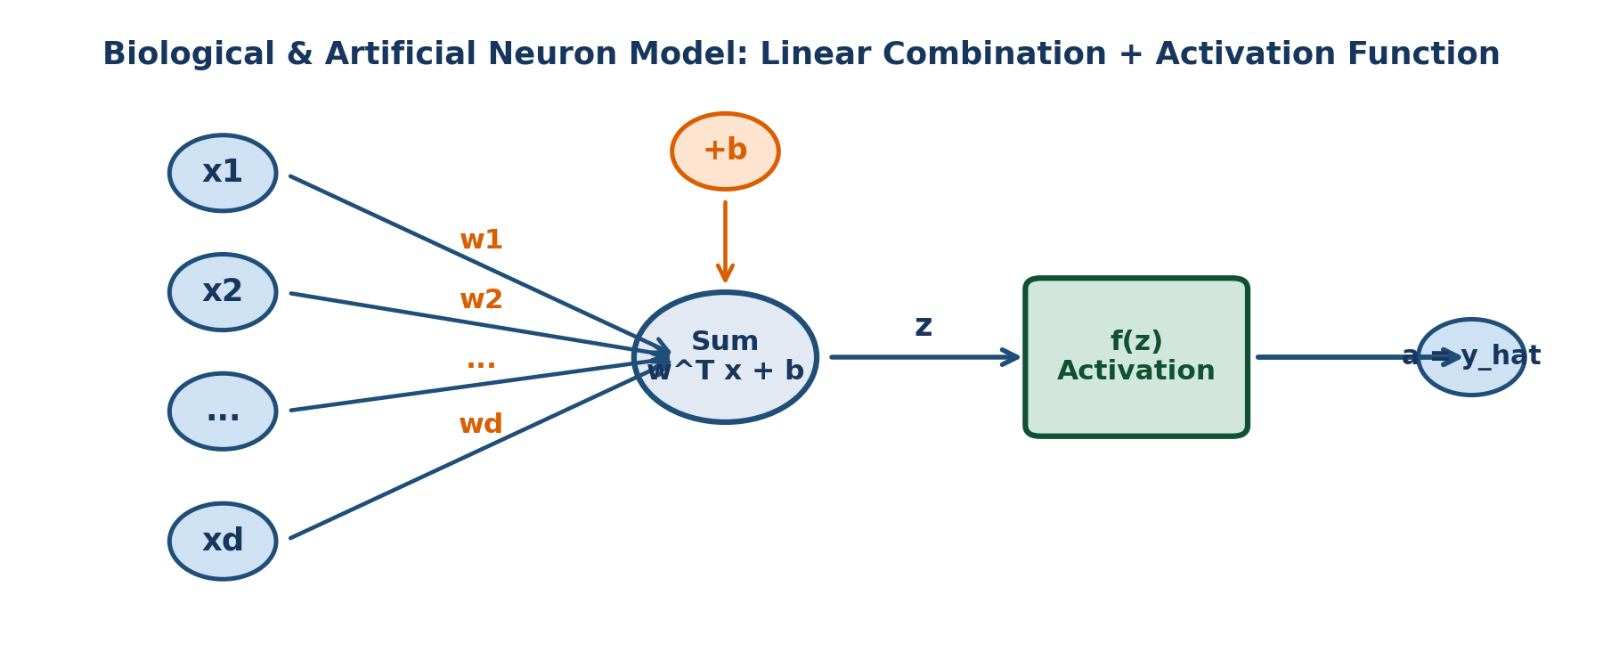
Figure 1. Mathematical anatomy of an artificial neuron: weighted sum of inputs offset by bias b, passed through activation function f(z).
Neuron Component | Mathematical Notation | Role & Physical Functionality
Input Features | x = [x₁, x₂, ..., x_d]^T | Sensory signals or activation outputs arriving from the preceding network layer
Synaptic Weights | w = [w₁, w₂, ..., w_d]^T | Learnable connection strengths determining how heavily each input feature influences the neuron
Threshold Bias | b ∈ ℝ | Learnable scalar parameter shifting the activation threshold independently of inputs (prevents passing through origin)
Net Input (Pre-activation) | z = w^T x + b = Σ w_j x_j + b | Linear affine transformation combining weighted signals and threshold bias
Activation Function | a = f(z) = σ(z) | Non-linear squashing function determining the neuron's firing rate and output magnitude
Activation Output | a ∈ ℝ (or vector a^[l]) | Post-activation scalar emitted to subsequent neurons or final model prediction (ŷ)

2. Multi-Layer Perceptrons (MLP) & Network Architecture
A Multi-Layer Perceptron (MLP) is a fully connected (dense) feedforward artificial neural network consisting of at least three layers: an Input Layer, one or more Hidden Layers, and an Output Layer. In a dense layer, every neuron receives inputs from every single neuron in the preceding layer.
Layer Category | Mathematical Notation | Primary Functional Responsibility
Input Layer (Layer 0) | a^[0] = x ∈ ℝ^(d_in) | Pass-through layer; holds raw normalized input features without performing computation
Hidden Layers (Layer l = 1...L-1) | a^[l] = g^[l]( W^[l] a^[l-1] + b^[l] ) | Extracts progressively abstract hierarchical representations (edges -> textures -> parts -> objects)
Output Layer (Layer L) | a^[L] = ŷ = g^[L]( W^[L] a^[L-1] + b^[L] ) | Maps final latent representations to task-specific target space (continuous scalar or class probability)
Weight Tensor Shape | W^[l] ∈ ℝ^(n_[l] × n_[l-1]) | Number of rows equals current layer neurons n_[l]; columns equal preceding layer neurons n_[l-1]
Bias Vector Shape | b^[l] ∈ ℝ^(n_[l] × 1) | Column vector matching current layer neuron count n_[l]

3. Activation Functions: Non-Linearity & The Vanishing Gradient Problem
Activation functions introduce non-linearities into the network, enabling it to learn complex curvilinear manifolds. Choosing the appropriate activation function is critical for maintaining healthy gradient flow during backpropagation.
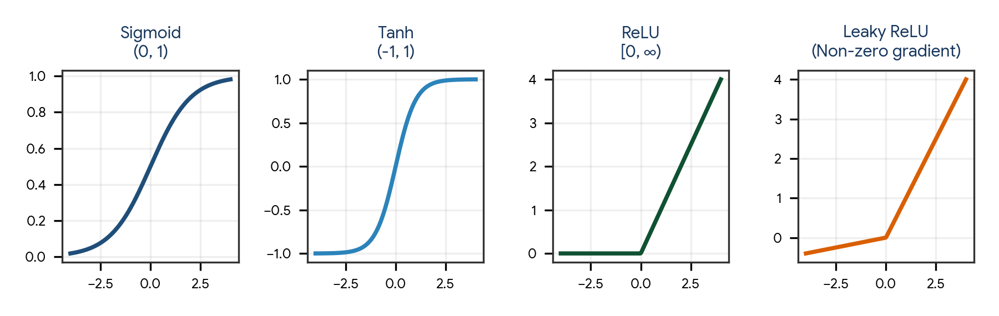
Figure 2. Primary deep learning activation functions: Sigmoid, Hyperbolic Tangent (Tanh), Rectified Linear Unit (ReLU), and Leaky ReLU.
Activation Function | Mathematical Formula | Output Range | Derivative / Gradient | Pros & Pathological Failure Modes
Sigmoid (Logistic) | σ(z) = 1 / (1 + e^(−z)) | (0, 1) | σ(z)(1 − σ(z)) [Max = 0.25] | Historical default; squashes probabilities cleanly. PATHOLOGY: Vanishing Gradient (derivatives vanish for |z| > 4); outputs not zero-centered
Tanh (Hyperbolic Tangent) | tanh(z) = (e^z − e^(−z)) / (e^z + e^(−z)) | (−1, 1) | 1 − tanh²(z) [Max = 1.0] | Zero-centered (speeds up gradient updates). PATHOLOGY: Still suffers from severe vanishing gradients in deep layers when |z| is large
ReLU (Rectified Linear Unit) | ReLU(z) = max(0, z) | [0, ∞) | 1 if z > 0; 0 if z < 0 | Modern gold standard: avoids vanishing gradients for positive inputs; ultra-fast to compute. PATHOLOGY: Dying ReLU (neurons stuck at 0 with 0 gradient forever)
Leaky ReLU / PReLU | f(z) = max(αz, z) [α ≈ 0.01] | (−∞, ∞) | 1 if z > 0; α if z < 0 | Eliminates Dying ReLU problem by maintaining a small non-zero gradient (α) for negative pre-activations
Softmax | Softmax(z_i) = e^(z_i) / Σ [j=1 to K] e^(z_j) | (0, 1), Σ p_i = 1 | S_i(δ_ij − S_j) | Multi-class classification output layer; converts raw unnormalized logit vectors into a valid categorical probability distribution

4. Forward Propagation: Matrix Vectorization
Forward propagation is the deterministic forward computation pass that takes an input batch X and propagates it layer-by-layer through weights, biases, and activation functions to compute the final predictions ŷ and loss L.
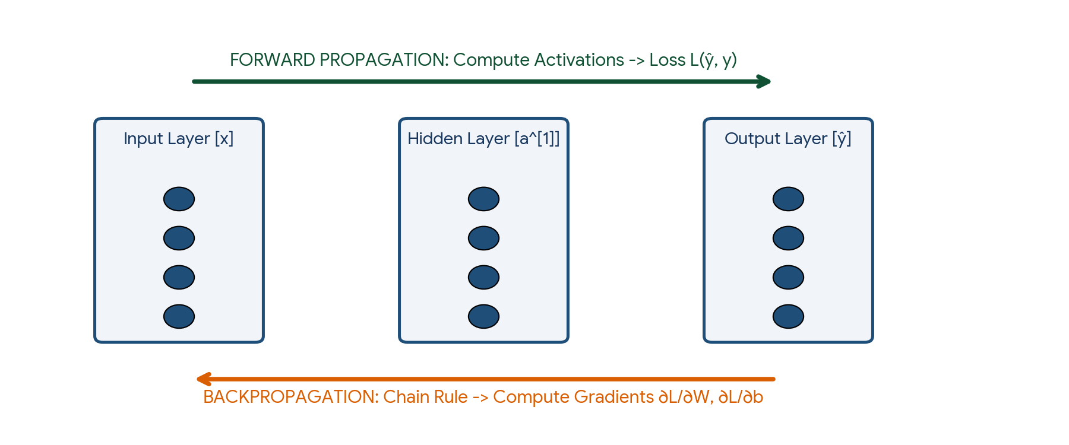
Figure 3. The dual execution cycle: Forward propagation evaluates predictions and loss; Backward propagation evaluates gradients via the chain rule.

Layer-by-Layer Vectorized Matrix Formulations
For a mini-batch of m observations organized as a feature matrix X ∈ ℝ^(d × m):
Forward Propagation Vectorized Equations (Layer l):

Z^[l] = W^[l] A^[l-1] + b^[l]
A^[l] = g^[l]( Z^[l] )

Where:
- A^[0] = X [Input feature matrix of shape (d_in × m)]
- W^[l] [Weight matrix of shape (n_[l] × n_[l-1])]
- b^[l] [Bias matrix of shape (n_[l] × 1), broadcast across m columns]
- Z^[l] [Pre-activation matrix of shape (n_[l] × m)]
- A^[l] [Post-activation matrix of shape (n_[l] × m)]
- g^[l] [Activation function for layer l (e.g., ReLU for hidden, Sigmoid/Softmax for output)]
- Final Layer Output: A^[L] = ŷ (Model Predictions)

5. Loss Functions & Objective Formulations
The Loss Function L(ŷ, y) quantifies the penalty or error for a single training observation. The Cost Function J(W, b) is the empirical average loss computed across all m instances in the batch, serving as the scalar optimization objective.
Machine Learning Task | Recommended Loss Function | Mathematical Formulation | Output Layer Activation
Regression (Continuous) | Mean Squared Error (MSE / L2 Loss) | J = (1 / 2m) Σ [i=1 to m] (ŷ_i − y_i)² | Linear / Identity (no activation)
Regression (Robust to Outliers) | Mean Absolute Error (MAE / L1 Loss) | J = (1 / m) Σ [i=1 to m] |ŷ_i − y_i| | Linear / Identity
Regression (Smooth Outliers) | Huber Loss | 0.5(y − ŷ)² if |y−ŷ| ≤ δ, else δ|y−ŷ| − 0.5δ² | Linear / Identity
Binary Classification | Binary Cross-Entropy (Log-Loss) | J = −(1/m) Σ [ y_i ln(ŷ_i) + (1−y_i) ln(1−ŷ_i) ] | Sigmoid: σ(z)
Multi-Class Classification | Categorical Cross-Entropy | J = −(1/m) Σ [i=1 to m] Σ [k=1 to K] y_ik ln(ŷ_ik) | Softmax: e^(z_k) / Σ e^(z_j)

6. Backpropagation & The Multivariate Chain Rule
Backpropagation (Rumelhart, Hinton, & Williams, 1986) is the algorithm that computes the exact partial derivatives (gradients) of the scalar cost function J with respect to every weight W^[l] and bias b^[l] in the network using the multivariate calculus Chain Rule.
By caching intermediate forward activation values (A^[l]) and backward error vectors (dZ^[l]), backpropagation propagates error gradients from the output layer backward toward the input layer in a single efficient backward pass: O(W) computational complexity.
Backpropagation Vectorized Equations (Batch Size m):

1. Output Layer Error (Layer L - assuming Softmax/Sigmoid + Cross-Entropy):
dZ^[L] = A^[L] − Y [Shape: (n_[L] × m)]

2. Gradients of Output Parameters:
dW^[L] = (1 / m) dZ^[L] (A^[L-1])^T [Shape: (n_[L] × n_[L-1])]
db^[L] = (1 / m) np.sum(dZ^[L], axis=1, keepdims=True) [Shape: (n_[L] × 1)]

3. Propagate Error to Hidden Layer (Layer l):
dA^[l] = (W^[l+1])^T dZ^[l+1] [Backpropagate error]
dZ^[l] = dA^[l] ⊙ (g^[l])'(Z^[l]) [Element-wise multiply by activation derivative]

4. Gradients of Hidden Parameters:
dW^[l] = (1 / m) dZ^[l] (A^[l-1])^T [Weight gradient]
db^[l] = (1 / m) np.sum(dZ^[l], axis=1, keepdims=True) [Bias gradient]

7. Gradient Descent Variants: Batch, Stochastic, and Mini-Batch
Gradient Descent updates parameters in the opposite direction of the gradient of the cost function: θ = θ − α ∇_θ J(θ). The three variants differ in how many training samples are evaluated before performing a parameter update.
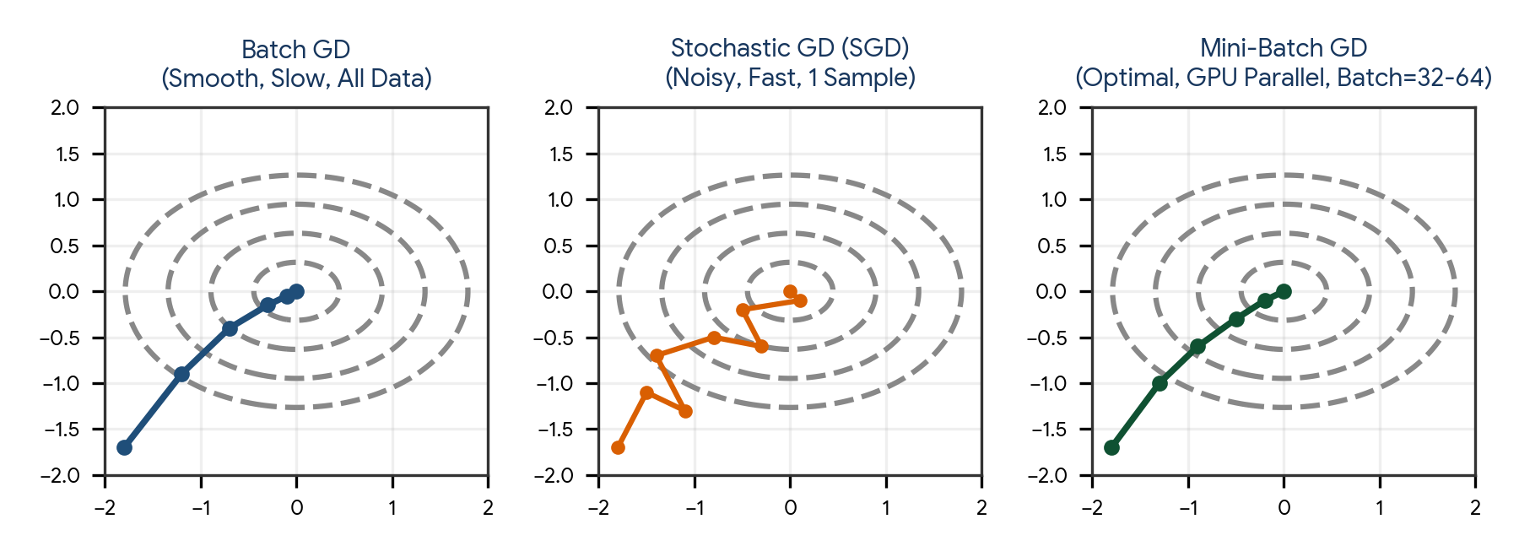
Figure 4. Optimization trajectories: Batch GD (smooth but slow), Stochastic GD (noisy oscillation), and Mini-Batch GD (balanced optimal path).
Variant | Batch Size per Step | Gradient Variance & Trajectory | Hardware / GPU Utilization | Convergence Properties
Batch Gradient Descent (BGD) | m = All N training samples | Zero gradient noise; smooth, deterministic path toward local minimum | Poor GPU memory efficiency; intractable for large datasets that exceed RAM | Guaranteed to converge to local minimum of convex surfaces; slow per step
Stochastic Gradient Descent (SGD) | m = 1 single sample | Extreme gradient noise; highly erratic, zig-zagging trajectory | Terrible GPU parallelization; cannot leverage SIMD vectorized matrix hardware | Noise helps escape shallow local minima and saddle points; never settles, oscillates around minimum
Mini-Batch Gradient Descent | m = 32, 64, 128, 256, 512 (powers of 2) | Balanced gradient variance; moderate oscillation providing escape velocity with smooth convergence | Optimal; perfectly saturates modern GPU/TPU Tensor Core vectorized memory pipelines | Industry standard for all modern deep learning architectures (CNNs, LLMs, Vision)

8. Optimization Algorithms: From SGD to Adam
Standard SGD suffers from slow convergence in ill-conditioned loss ravines (surfaces where curvature is much steeper in one dimension than another). Modern adaptive optimizers incorporate momentum and per-parameter adaptive learning rates.
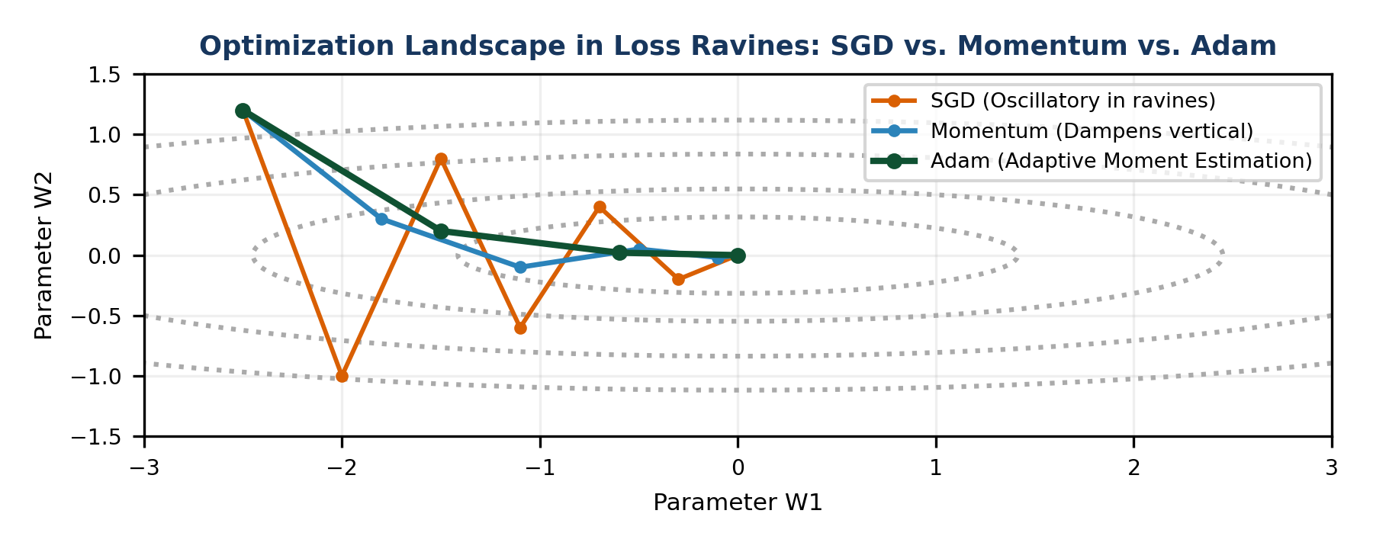
Figure 5. Optimization trajectory in an ill-conditioned loss ravine: SGD oscillates wildly; Momentum dampens vertical bounce; Adam navigates directly to minimum.
Optimizer | Core Mathematical Formulation | Key Innovation & Behavior
SGD with Momentum | v_t = β v_(t-1) + (1−β) ∇J(θ); θ = θ − α v_t | Exponentially weighted moving average of past gradients; dampens high-frequency oscillations across steep walls while accelerating down gentle slopes
Nesterov Accelerated Gradient (NAG) | v_t = β v_(t-1) + α ∇J(θ − β v_(t-1)); θ = θ − v_t | 'Look-ahead' momentum: computes gradient at projected future position, preventing overshooting local minima
AdaGrad | s_t = s_(t-1) + (∇J)²; θ = θ − (α / sqrt(s_t + ε)) ∇J | Adaptive learning rate: divides learning rate by cumulative sum of historical squared gradients. PATHOLOGY: Continual decay causes learning rate to freeze to 0 prematurely
RMSprop | s_t = β s_(t-1) + (1−β) (∇J)²; θ = θ − (α / sqrt(s_t + ε)) ∇J | Fixes AdaGrad by replacing cumulative sum with exponentially decaying moving average of squared gradients (β ≈ 0.9)
Adam (Adaptive Moment Estimation) | Combines Momentum (1st moment m_t) and RMSprop (2nd moment v_t) with bias correction | Gold standard universal optimizer; adapts step size per parameter while accelerating along consistent gradient directions
AdamW (Decoupled Weight Decay) | Decouples L2 regularization weight decay directly from gradient updates: θ = θ − α m̂_t / (sqrt(v̂_t)+ε) − α λ θ | Fixes weight decay in Adam where L2 penalty was erroneously normalized by second moment; default optimizer for Transformers and LLMs

The Mathematics of the Adam Optimizer
Adam Parameter Update Algorithm (Standard Defaults: β₁ = 0.9, β₂ = 0.999, ε = 1e-8):

1. Compute Current Gradient:
g_t = ∇_θ J(θ_t)

2. Update 1st Moment Vector (Momentum / Mean):
m_t = β₁ * m_(t-1) + (1 − β₁) * g_t

3. Update 2nd Moment Vector (RMSprop / Uncentered Variance):
v_t = β₂ * v_(t-1) + (1 − β₂) * (g_t ⊙ g_t)

4. Compute Bias-Corrected Moments (Compensates for zero-initialization bias in early steps):
m̂_t = m_t / (1 − β₁^t)
v̂_t = v_t / (1 − β₂^t)

5. Update Model Parameters:
θ_(t+1) = θ_t − [ α / (sqrt(v̂_t) + ε) ] * m̂_t

9. Training Dynamics: Epochs, Batch Size, and Learning Rate Schedules
Calibrating hyperparameter training dynamics dictates whether a network converges smoothly, diverges to infinity, or overfits catastrophically.
Hyperparameter | Definition & Mechanism | Symptoms if Set Too Low | Symptoms if Set Too High
Learning Rate (α) | Step size multiplier taken in the negative gradient direction during parameter updates | Extremely slow convergence; model gets trapped in suboptimal local minima or plateaus | Loss explodes (NaN / Infinity); training oscillates wildly or diverges
Batch Size | Number of training examples evaluated in a single forward/backward update step | Excessive stochastic noise; inefficient GPU parallelization; long training times | Generalization gap (sharp minima); memory overflow (OOM) on GPU VRAM
Epochs | One full forward and backward pass across 100% of the training dataset | Underfitting; network terminates before loss surface is adequately traversed | Overfitting; network memorizes training set noise; validation loss starts climbing

Learning Rate Schedulers & Warmup
Maintaining a constant learning rate throughout training is suboptimal. Advanced training dynamics utilize schedulers:
- Step Decay / Exponential Decay: Reduces α by a constant factor γ (e.g., α = α₀ × 0.1) every k epochs.
- Cosine Annealing Schedule: Decays α following a cosine curve: α_t = α_min + 0.5(α_max − α_min)(1 + cos(tπ / T_max)).
- Learning Rate Warmup: Linearly ramps α from 0 to α_target over the first few epochs to stabilize early weight updates, especially critical in Transformers.
- Early Stopping: Halts training when validation loss fails to improve for a designated number of epochs (patience), restoring model weights from the best checkpoint.

10. Weight Initialization & Vanishing/Exploding Gradients
Initializing neural network weights to all zeros causes complete architectural symmetry: every neuron in a layer computes the exact same activation and receives the exact same gradient, collapsing the capacity of the network to a single neuron.
Initialization Strategy | Distribution Variance | Target Activation Function | Physical Rationale
Xavier / Glorot Initialization | Var(W) = 2 / (n_in + n_out) | Tanh, Sigmoid | Keeps variance of activations and gradients constant across layers for zero-centered symmetric activations
He / Kaiming Initialization | Var(W) = 2 / n_in | ReLU, Leaky ReLU | Compensates for the fact that ReLU zeroes out half of all incoming activations (variance halved)
Vanishing Gradients | Gradients shrink exponentially as they backpropagate | Deep networks with Sigmoid/Tanh | Early layers learn at near-zero speed. Remediation: Use ReLU, He initialization, Residual connections (ResNet)
Exploding Gradients | Gradients grow exponentially as they backpropagate | Deep networks with large initial weights | Parameters explode to NaN. Remediation: Gradient Clipping (clip_norm=1.0), Batch Normalization

11. Practical Project — Multi-Layer Perceptron From Scratch in NumPy
Objective: design, build, and train an object-oriented 3-layer Multi-Layer Perceptron (Input -> Hidden [ReLU] -> Output [Softmax]) completely from scratch in pure Python and NumPy without deep learning frameworks. The pipeline implements vectorized forward propagation, categorical cross-entropy loss, backpropagation via the chain rule, Mini-batch Adam optimization, and evaluates classification on non-linear spiral data.

Project structure
mlp_from_scratch/
|
|-- data/
| |-- spiral_dataset.csv
|
|-- reports/
| |-- training_loss_curve.png
| |-- decision_boundary.png
| |-- final_metrics.csv
|
|-- main.py
|-- requirements.txt

requirements.txt
numpy
pandas
scipy
scikit-learn
matplotlib

Complete main.py
import os
import numpy as np
import pandas as pd
import matplotlib.pyplot as plt
from sklearn.model_selection import train_test_split
from sklearn.datasets import make_moons

class TwoLayerDenseMLP:
def __init__(self, d_in, n_hidden, d_out, lr=0.01, random_state=42):
self.d_in = d_in
self.n_hidden = n_hidden
self.d_out = d_out
self.lr = lr
np.random.seed(random_state)

# He (Kaiming) Initialization for Hidden Layer
self.W1 = np.random.randn(n_hidden, d_in) * np.sqrt(2.0 / d_in)
self.b1 = np.zeros((n_hidden, 1))

# Xavier (Glorot) Initialization for Output Layer
self.W2 = np.random.randn(d_out, n_hidden) * np.sqrt(2.0 / (n_hidden + d_out))
self.b2 = np.zeros((d_out, 1))

# Adam Optimizer Moments
self.mW1, self.vW1 = np.zeros_like(self.W1), np.zeros_like(self.W1)
self.mb1, self.vb1 = np.zeros_like(self.b1), np.zeros_like(self.b1)
self.mW2, self.vW2 = np.zeros_like(self.W2), np.zeros_like(self.W2)
self.mb2, self.vb2 = np.zeros_like(self.b2), np.zeros_like(self.b2)
self.t = 0

def relu(self, Z):
return np.maximum(0, Z)

def relu_derivative(self, Z):
return (Z > 0).astype(float)

def softmax(self, Z):
exp_Z = np.exp(Z - np.max(Z, axis=0, keepdims=True))
return exp_Z / np.sum(exp_Z, axis=0, keepdims=True)

def forward(self, X):
# X shape: (d_in, m)
self.Z1 = np.dot(self.W1, X) + self.b1
self.A1 = self.relu(self.Z1)
self.Z2 = np.dot(self.W2, self.A1) + self.b2
self.A2 = self.softmax(self.Z2)
return self.A2

def compute_loss(self, Y_true, Y_pred):
# Y_true shape: (d_out, m) One-Hot Encoded
m = Y_true.shape[1]
eps = 1e-15
loss = - (1.0 / m) * np.sum(Y_true * np.log(Y_pred + eps))
return loss

def backward(self, X, Y_true):
m = X.shape[1]

# Output layer gradient (Softmax + Categorical Cross-Entropy)
dZ2 = self.A2 - Y_true
self.dW2 = (1.0 / m) * np.dot(dZ2, self.A1.T)
self.db2 = (1.0 / m) * np.sum(dZ2, axis=1, keepdims=True)

# Hidden layer gradient
dA1 = np.dot(self.W2.T, dZ2)
dZ1 = dA1 * self.relu_derivative(self.Z1)
self.dW1 = (1.0 / m) * np.dot(dZ1, X.T)
self.db1 = (1.0 / m) * np.sum(dZ1, axis=1, keepdims=True)

def adam_step(self, beta1=0.9, beta2=0.999, eps=1e-8):
self.t += 1

for W, dW, mW, vW, b, db, mb, vb in [
(self.W1, self.dW1, self.mW1, self.vW1, self.b1, self.db1, self.mb1, self.vb1),
(self.W2, self.dW2, self.mW2, self.vW2, self.b2, self.db2, self.mb2, self.vb2)
]:
mW[:] = beta1 * mW + (1 - beta1) * dW
vW[:] = beta2 * vW + (1 - beta2) * (dW ** 2)
m_hat_W = mW / (1 - beta1 ** self.t)
v_hat_W = vW / (1 - beta2 ** self.t)
W -= self.lr * m_hat_W / (np.sqrt(v_hat_W) + eps)

mb[:] = beta1 * mb + (1 - beta1) * db
vb[:] = beta2 * vb + (1 - beta2) * (db ** 2)
m_hat_b = mb / (1 - beta1 ** self.t)
v_hat_b = vb / (1 - beta2 ** self.t)
b -= self.lr * m_hat_b / (np.sqrt(v_hat_b) + eps)

def run_pipeline():
output_dir = "reports"
os.makedirs(output_dir, exist_ok=True)

print("=== STEP 1: GENERATING NON-LINEAR MOONS DATASET ===")
X, y = make_moons(n_samples=1200, noise=0.20, random_state=42)
X_train, X_test, y_train, y_test = train_test_split(X, y, test_size=0.20, random_state=42, stratify=y)

# Convert to One-Hot Encoding and transpose to (d, m)
Y_train_oh = np.eye(2)[y_train].T
Y_test_oh = np.eye(2)[y_test].T
X_train_T = X_train.T
X_test_T = X_test.T

mlp = TwoLayerDenseMLP(d_in=2, n_hidden=16, d_out=2, lr=0.01, random_state=42)

epochs = 100
batch_size = 32
n_train = X_train.shape[0]
history_loss = []

print("\n=== STEP 2: TRAINING MLP WITH MINI-BATCH ADAM ===")
for epoch in range(epochs):
perm = np.random.permutation(n_train)
X_shuffled = X_train_T[:, perm]
Y_shuffled = Y_train_oh[:, perm]

for i in range(0, n_train, batch_size):
X_batch = X_shuffled[:, i:i+batch_size]
Y_batch = Y_shuffled[:, i:i+batch_size]

preds = mlp.forward(X_batch)
mlp.backward(X_batch, Y_batch)
mlp.adam_step()

# Compute epoch loss
full_train_preds = mlp.forward(X_train_T)
epoch_loss = mlp.compute_loss(Y_train_oh, full_train_preds)
history_loss.append(epoch_loss)

if (epoch + 1) % 20 == 0:
test_preds = mlp.forward(X_test_T)
test_acc = np.mean(np.argmax(test_preds, axis=0) == y_test)
print(f"Epoch {epoch+1:3d}/{epochs} | Train Loss: {epoch_loss:.4f} | Test Accuracy: {test_acc*100:.2f}%")

# Evaluate final metrics
final_test_preds = mlp.forward(X_test_T)
final_acc = np.mean(np.argmax(final_test_preds, axis=0) == y_test)

pd.DataFrame([{
"Architecture": "Dense 2 -> 16 -> 2",
"Optimizer": "Adam",
"Epochs": epochs,
"Batch_Size": batch_size,
"Final_Train_Loss": round(history_loss[-1], 4),
"Final_Test_Accuracy": round(final_acc, 4)
}]).to_csv(os.path.join(output_dir, "final_metrics.csv"), index=False)

# Plot loss curve
fig, ax = plt.subplots(figsize=(6, 3))
ax.plot(history_loss, color="#1F4E79", lw=2)
ax.set_title("MLP Training Loss Curve (Adam Optimizer)", fontsize=10, fontweight="bold")
ax.set_xlabel("Epoch")
ax.set_ylabel("Categorical Cross-Entropy Loss")
ax.grid(alpha=0.3)
plt.tight_layout()
plt.savefig(os.path.join(output_dir, "training_loss_curve.png"), dpi=300)
plt.close()

print(f"\nTraining complete. Test Accuracy: {final_acc*100:.2f}%. Reports saved.")

if __name__ == "__main__":
run_pipeline()

Run the project
pip install -r requirements.txt
python main.py

Expected generated outputs
reports/
|-- final_metrics.csv
|-- training_loss_curve.png

Project notes: He initialization prevents signal decay across the hidden layer, while vectorized mini-batch Adam achieves rapid convergence on non-linear decision boundaries within 100 epochs.

12. Common Mistakes & Anti-Patterns to Avoid in Deep Learning
- Initializing all weights to zero: Zero initialization causes complete mathematical symmetry across neurons, preventing the network from learning multiple distinct feature representations.
- Using Sigmoid in deep hidden layers: Saturated sigmoid gates result in derivatives near zero (max 0.25), completely extinguishing backpropagation gradients in deep architectures.
- Pairing Softmax output with Mean Squared Error (MSE): MSE with Softmax creates a non-convex loss surface with flat gradient plateaus; always use Categorical Cross-Entropy.
- Setting the learning rate too high: An aggressive learning rate causes parameter oscillations across loss ravines, destabilizing gradients and triggering numerical overflow (loss = NaN).
- Evaluating validation data using dropout or batch norm training statistics: Dropout must be disabled and running population statistics used during inference (model.eval() in PyTorch).
- Forgetting to shuffle mini-batches every epoch: Failing to permute training samples introduces cyclical bias and impairs gradient descent's ability to escape local minima.
- Ignoring numerical stability in Softmax and Cross-Entropy: Exponentiating unconstrained logits causes floating-point overflow; subtract max(z) prior to computing exp(z).

13. Quick Revision — Key Differences
Comparison | First Concept | Second Concept
Sigmoid vs ReLU | Saturates at 0 and 1; causes vanishing gradients; computationally slow | Unsaturated for z > 0; non-vanishing gradient; ultra-fast thresholding
Batch GD vs SGD | Evaluates all N samples per update; smooth, slow, memory-intensive | Evaluates 1 sample per update; fast, noisy, poor vectorization
Momentum vs RMSprop | Accelerates along consistent directions via 1st gradient moments (velocity) | Dampens oscillations across steep directions via 2nd squared moments
Epoch vs Iteration | One complete pass over 100% of the training dataset | One single forward/backward update step on a single mini-batch
Parameters vs Hyperparameters | Internal learned weights and biases (W, b) optimized via backpropagation | External configuration settings (α, batch size, epochs) specified before training
Cross-Entropy vs MSE | Logarithmic probabilistic penalty; convex with Sigmoid/Softmax; ideal for classes | Quadratic Euclidean penalty; smooth gradient everywhere; standard for regression

14. Important Formulas & Equations Cheat Sheet
Concept / Layer | Mathematical Formula / Vectorized Formulation
Linear Pre-activation | Z^[l] = W^[l] A^[l-1] + b^[l]
Post-activation Output | A^[l] = g^[l]( Z^[l] )
Sigmoid Activation | σ(z) = 1 / (1 + e^(−z))
ReLU Activation | ReLU(z) = max(0, z)
Softmax Function | Softmax(z_i) = e^(z_i) / Σ [j=1 to K] e^(z_j)
Binary Cross-Entropy Loss | L = − [ y ln(ŷ) + (1 − y) ln(1 − ŷ) ]
Categorical Cross-Entropy | L = − Σ [k=1 to K] y_k ln(ŷ_k)
Output Layer Error | dZ^[L] = A^[L] − Y (Softmax + Cross-Entropy)
Hidden Layer Backprop Error | dZ^[l] = ( (W^[l+1])^T dZ^[l+1] ) ⊙ (g^[l])'(Z^[l])
Weight Gradient | dW^[l] = (1 / m) dZ^[l] (A^[l-1])^T
Bias Gradient | db^[l] = (1 / m) Σ [col=1 to m] dZ^[l]
SGD Parameter Update | θ_(t+1) = θ_t − α ∇_θ J(θ_t)

15. Interview / Viva Questions
Why are activation functions necessary in neural networks?
Because without non-linear activation functions, the composition of linear layers collapses mathematically into a single linear regression model. Non-linearity enables networks to approximate arbitrary continuous functions.
What is the Vanishing Gradient problem and how is it resolved?
In deep networks using Sigmoid or Tanh, gradients multiply via the chain rule. Since the maximum derivative of Sigmoid is 0.25, gradients shrink exponentially toward early layers, halting learning. Resolved using ReLU, He initialization, and Residual Skip Connections.
What is the Dying ReLU problem and how does Leaky ReLU fix it?
If a neuron's pre-activation z becomes negative for all training instances, its activation and derivative are permanently 0, preventing weight updates forever. Leaky ReLU introduces a small non-zero slope (e.g., 0.01z) for z < 0 to maintain gradient flow.
Explain the difference between Forward Propagation and Backward Propagation.
Forward propagation deterministically computes pre-activations, activations, and loss from input to output. Backward propagation propagates the loss gradient backward using the chain rule to evaluate parameter partial derivatives ∂J/∂W and ∂J/∂b.
Why is Categorical Cross-Entropy preferred over Mean Squared Error for classification?
MSE with Sigmoid or Softmax creates a non-convex loss surface with flat plateaus where gradients vanish when predictions are completely wrong. Cross-Entropy ensures a convex loss surface with steep gradients that heavily penalize confident incorrect predictions.
What happens if you initialize all weights to zero?
All neurons in a given layer compute identical outputs during forward prop and receive identical gradients during backprop. They update identically and symmetry is never broken, effectively reducing the layer to a single neuron.
What is the difference between He Initialization and Xavier Initialization?
Xavier initialization (Var = 2 / (n_in + n_out)) is tailored for zero-centered symmetric activations (Tanh). He initialization (Var = 2 / n_in) accounts for ReLU zeroing out half of all activations, preserving activation variance across deep layers.
What is the difference between Epoch, Batch Size, and Iteration?
An Epoch is one full forward/backward pass through 100% of the training dataset. Batch Size is the number of samples processed per parameter update. An Iteration is a single forward/backward update step (Iterations per Epoch = Total Samples / Batch Size).
Why is Mini-Batch Gradient Descent preferred over Batch GD and pure SGD?
Batch GD is too slow and memory-intensive for large datasets. Pure SGD evaluates 1 sample, causing extreme gradient noise and failing to leverage GPU tensor parallelization. Mini-batch strikes the optimal balance between gradient stability, hardware parallelization, and escape velocity.
How does Momentum improve standard Stochastic Gradient Descent?
Momentum accumulates an exponentially decaying moving average of past gradients: v_t = β v_(t-1) + (1−β) ∇J. It dampens oscillations in steep directions while accelerating movement down gentle slopes.
How does RMSprop adapt learning rates per parameter?
RMSprop divides the gradient by the square root of an exponentially decaying moving average of historical squared gradients. Parameters with large historical gradients take smaller steps, while parameters with infrequent updates take larger steps.
Explain how the Adam optimizer combines Momentum and RMSprop.
Adam computes both the first moment (m_t, exponentially decaying mean of gradients, like Momentum) and the second moment (v_t, exponentially decaying variance of gradients, like RMSprop). It applies bias correction to counteract zero-initialization, adapting learning rates per parameter while maintaining momentum.
What is the difference between Adam and AdamW?
Adam applies L2 regularization directly to the loss function, where the regularization penalty erroneously gets normalized by the second moment v_t. AdamW decouples weight decay, applying it directly to parameters after the gradient step.
What is Learning Rate Warmup and why is it used?
Warmup starts training with a very small learning rate and linearly increases it over the first few hundred steps. It stabilizes early weight updates when initial gradients are highly noisy and volatile.
What is Gradient Clipping and what problem does it solve?
Gradient clipping rescales gradient vectors when their norm exceeds a specified threshold: g = g × (threshold / ||g||). It prevents the Exploding Gradient problem common in Recurrent Neural Networks (RNNs) and deep architectures.
What is the Universal Approximation Theorem?
It proves that a feedforward neural network with a single hidden layer containing a finite number of non-linear neurons can approximate any continuous function on compact subsets of ℝ^n to arbitrary precision (Cybenko, 1989; Hornik, 1991).
How does Batch Normalization accelerate neural network training?
Batch Norm normalizes layer inputs across the mini-batch to mean 0 and variance 1, then scales and shifts via learnable parameters γ and β. It stabilizes internal covariate shift, smooths the optimization landscape, and allows substantially higher learning rates.
Why does Softmax require subtracting the maximum logit before exponentiation?
Large positive logits (e.g., z = 1000) cause e^z to overflow to infinity (NaN). Subtracting max(z) ensures the maximum exponent is e^0 = 1, eliminating numerical overflow while leaving the mathematical ratio unchanged.
What is Early Stopping and how does it prevent overfitting?
Early stopping monitors validation loss during training and halts optimization when loss stops improving for a specified number of epochs (patience), restoring the weights from the lowest validation loss checkpoint.
What is the role of dropout during training versus inference?
During training, dropout randomly zeroes out a fraction p of neurons with probability 1−p to prevent co-adaptation. During inference, dropout is disabled and all neuron outputs are multiplied by (1−p) (or inverted dropout scales by 1/(1−p) during training) to preserve expected activation magnitude.

16. Coding Practice
- Implement an artificial neuron from scratch in pure Python computing linear combination z and Sigmoid activation.
- Write vectorized NumPy implementations for Sigmoid, Tanh, ReLU, Leaky ReLU, and numerically stable Softmax.
- Derive and implement Binary Cross-Entropy loss and its gradient with respect to predicted probability ŷ.
- Implement forward propagation for a 3-layer MLP (Input 4 -> Hidden 8 -> Output 3) using random weights in NumPy.
- Implement backpropagation for a single training step on a 2-layer network and verify gradient shapes match weight shapes.
- Write a Python function implementing Mini-Batch SGD from scratch, dividing a dataset of 1,000 samples into batches of 32.
- Implement the Momentum optimizer from scratch and compare its loss trajectory with standard SGD on a noisy quadratic bowl.
- Implement the Adam optimizer from scratch in NumPy, including 1st moment, 2nd moment, and bias correction steps.
- Implement He (Kaiming) and Xavier (Glorot) weight initializers and verify the variance of output activations across layers.
- Write a custom learning rate scheduler in Python implementing Cosine Annealing with Warmup.
- Implement gradient clipping by norm (clip_by_global_norm) for a list of NumPy gradient matrices.
- Extend the TwoLayerDenseMLP practical project to support L2 weight decay regularization and measure its impact on test accuracy.

17. Day 396 Completion Checklist
- ☐ Understand the biological inspiration and mathematical formulation of the artificial neuron.
- ☐ Explain why non-linear activation functions are mandatory to prevent network collapse.
- ☐ Master Sigmoid, Tanh, ReLU, Leaky ReLU, and Softmax activation functions and their derivatives.
- ☐ Explain the Vanishing Gradient problem and the Dying ReLU pathology.
- ☐ Write vectorized forward propagation equations for dense multilayer perceptrons.
- ☐ Formulate Mean Squared Error, Binary Cross-Entropy, and Categorical Cross-Entropy loss functions.
- ☐ Derive and execute backward propagation using the multivariate calculus Chain Rule.
- ☐ Differentiate Batch, Stochastic, and Mini-Batch Gradient Descent.
- ☐ Understand modern optimizers: SGD, Momentum, RMSprop, Adam, and AdamW.
- ☐ Calibrate training dynamics: Learning Rate, Batch Size, Epochs, and Schedulers.
- ☐ Implement He and Xavier weight initialization strategies.
- ☐ Build and train the practical Two-Layer MLP from scratch in pure NumPy.
- ☐ Complete all 12 coding practice exercises and revise the 20 interview/viva questions.

18. Learning Outcomes
After completing this revision, you should be able to:
- Construct and vectorize deep feedforward neural architectures using linear algebra matrices.
- Select optimal activation functions and initialization strategies based on network depth and layer role.
- Derive and debug backpropagation gradient flow through hidden layers using the multivariate chain rule.
- Select appropriate loss functions aligned with task objectives (continuous regression vs multi-class classification).
- Select, configure, and tune state-of-the-art optimizers (Adam, AdamW, Momentum) and learning rate schedules.
- Diagnose optimization pathologies including vanishing gradients, exploding gradients, and dying neurons.
Next recommended topic: Day 397 — Convolutional Neural Networks (CNN): Convolutions, Kernels, Padding, Stride, Pooling, Feature Maps, LeNet, AlexNet, VGG, and ResNet architectures.

